Mechatronics System Integration (MCTA3203)
Week #3: Serial Communication (ver. 4.0)
Serial Communication between Arduino and Python
Table of Contents

- Experiment 1: Reading Potentiometer Values via Serial Communication
- Task 1
- Experiment 2: Controlling Servo Motor via Serial Communication
- Task 2

Experiment 1: Reading Potentiometer Values via Serial Communication

Objective:
To transmit potentiometer readings from Arduino to Python via USB serial.

1. Required Hardware:
- Arduino board
- Potentiometer
- Jumper wires
- Breadboard

2. Connections:
Connect the potentiometer to the Arduino. Wire one end of the potentiometer to 5V, the other end to GND, and the center pin to an analog input pin on the Arduino, e.g., A0 (see Fig. 1).
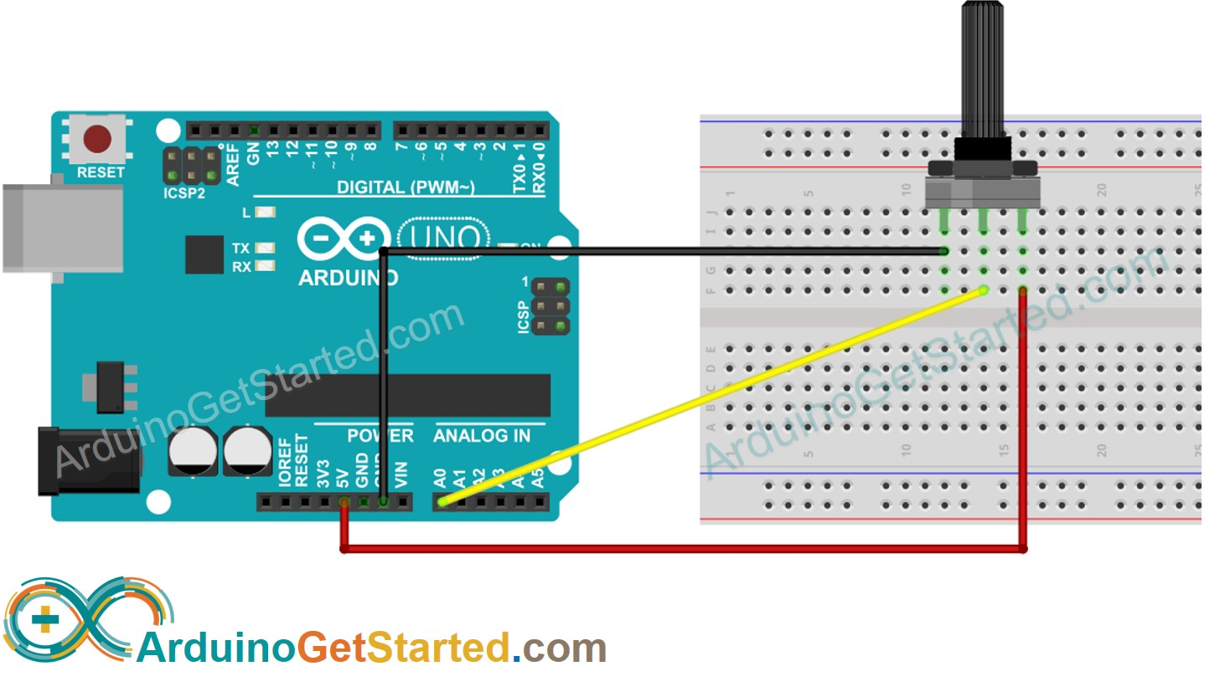

Fig. 1. Wiring Diagram

3. Arduino Code:
Write an Arduino code/sketch to read the potentiometer value and send it over the serial port. Here's a basic example:

void setup() {
Serial.begin(9600);
}

void loop() {
int potValue = analogRead(A0);
Serial.println(potValue);
delay(1000); // add a delay to avoid sending data too fast
}

Upload this code/sketch to your Arduino.

4. Python Script:
You can use Python (IDLE or PyCharm) to read the data from the Arduino via the serial port.
Setting Up Python and PyCharm
4.1. Software Installation
- Python: Download and install the latest version from python.org. Crucial: During installation, you must check the box that says "Add Python to PATH".
- PyCharm: Download and install the free PyCharm Community Edition.
4.2. Project & Library Setup
- Open PyCharm, click New Project, and click Create (the default Virtualenv settings are fine).
- Open the Terminal tab at the bottom of the PyCharm window.
- Install the required libraries by typing this single command and pressing Enter:
pip install pyserial matplotlib

Here's a basic Python script to read the potentiometer data:

import serial

# -- Replace 'COMx' with your Arduino's serial port
ser = serial.Serial('COMx', 9600)

try:
while True:
pot_value = ser.readline().decode().strip()
print("Potentiometer Value:", pot_value)
except KeyboardInterrupt:
ser.close()
print("Serial connection closed.")

4.3 Run the Python Script.
- Right-click your project folder on the left, select New -> Python File, and paste the Python script from the manual into it .
- Configure Port: Change the 'COMx' line in the Python script to match your Arduino's actual port (e.g., 'COM3') . You can check this in the Arduino IDE under Tools > Port.
- Avoid Conflicts: Ensure the Arduino IDE's Serial Monitor and Serial Plotter are completely CLOSED . If they are open, PyCharm will be blocked from accessing the Arduino.
- Execute: Right-click inside your code window and select Run. To stop the program safely, click the red "Stop" square in PyCharm or press CTRL+C in the terminal window.

Task 1

Required Hardware:
- Arduino board
- Potentiometer
- LED
- 220 Ω resistor
- Jumper wires
- Breadboard

Connections:
- See Fig. 2

Experiment Steps:
- Connect the Arduino to your computer via a USB cable.
- Extend the circuit by adding an LED to digital pin 7 in series with a 220 Ω resistor connected to GND.
- We will now establish bidirectional communication. The Arduino will send the potentiometer values to Python, and Python will send a command back to turn the LED ON if the value exceeds half its maximum range (ADC > 512).

- Ensure that Arduino IDE is not opened when running python code in pycharm. Otherwise, it will give an error.
- Ensure that the COM in python is adjusted according to the connection as shown in Arduino IDE

Schematic Diagram:
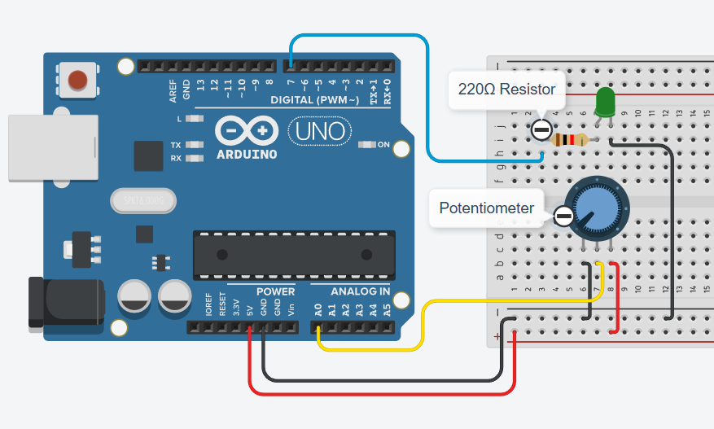
Fig.2

Arduino Code (Bidirectional):

const int potPin = A0;
const int ledPin = 7;
const float Vin = 5.0;
const float R_total = 10000.0;
String command = "";

void setup() {
Serial.begin(9600);
pinMode(ledPin, OUTPUT);
digitalWrite(ledPin, LOW);
}

void loop() {
int potValue = analogRead(potPin);
float Vout = (potValue / 1023.0) * Vin;
float R_wiper = (Vout / Vin) * R_total;

// Send formatted data to Python
Serial.print(Vout);
Serial.print(" / ADC: ");
Serial.print(potValue);
Serial.print(" / R: ");
Serial.println(R_wiper);

// Check for incoming commands from Python
if (Serial.available() > 0) {
command = Serial.readStringUntil('\n');
command.trim();

if (command == "LED ON") {
digitalWrite(ledPin, HIGH);
}
else if (command == "LED OFF") {
digitalWrite(ledPin, LOW);
}
}
delay(500);
}

Python Script (Bidirectional):

import serial
import time

# -- Replace 'COMx' with your Arduino's serial port
ser = serial.Serial('COMx', 9600)
time.sleep(2) # Wait for Arduino to reset

print("Running... Press CTRL+C to stop.")

try:
while True:
line = ser.readline().decode().strip()
if "/" in line:
try:
# Parse Arduino data
data = line.split("/")
voltage = float(data[0])
adc_value = int(data[1].replace("ADC:", "").strip())
resistance = float(data[2].replace("R:", "").strip())

print(f"Voltage: {voltage:.2f} V | ADC: {adc_value} | Resistance: {resistance:.2f} Ω")

# LED Control Logic
if adc_value > (1023 / 2):
ser.write(b"LED ON\n")
else:
ser.write(b"LED OFF\n")
except Exception as e:
print("Parsing Error:", line, "->", e)

except KeyboardInterrupt:
print("\nStopped by user.")
finally:
ser.close()
print("Serial connection closed.")

Experiment 2: Controlling Servo Motor via Serial Communication

Objective:
- To control servo motor angles using Python input transmitted to Arduino.
- Visualize sensor data graphically on the computer.

Required Hardware:
- Arduino Board + USB cable
- Servo Motor
- Jumper Wires
- Potentiometer

An example of the hardware setup is shown in Fig. 2 (Signal → pin 9, Vcc → 5V, GND → GND)

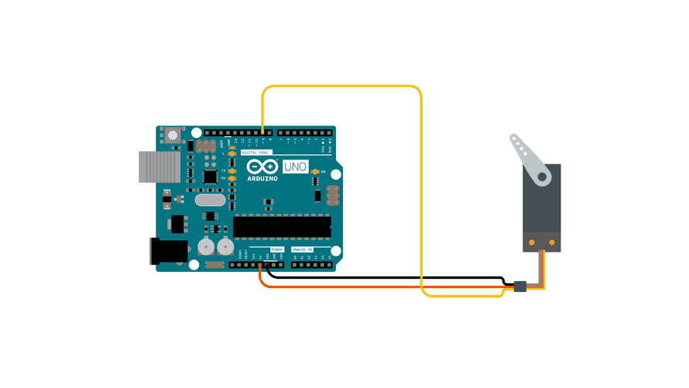
Fig. 2

Install Servo Libraries:
- Open the Arduino IDE.
- Go to Sketch > Include Library > Servo to install the Servo library.

Write the Arduino Code:
- Open a new sketch in the Arduino IDE.
- Write the Arduino code that reads angle data from the serial port and moves the servo accordingly.

Arduino Code:

#include <Servo.h>

Servo myservo; // to control a servo
int pos = 0; // variable to store the servo position

void setup() {
Serial.begin(9600);
myservo.attach(9); // attaches the servo on pin 9
}

void loop() {
// Check if data is available to read from Python
if (Serial.available() > 0) {
// Read the incoming integer
int angle = Serial.parseInt();

// Ensure the angle is within safe servo limits
if (angle >= 0 && angle <= 180) {
myservo.write(angle);
delay(15);
}
}
}

- Upload the code to your Arduino board

Install Required Python Libraries:
- Open a terminal or command prompt.
- Install the pyserial library using pip, if you haven’t it:
pip install pyserial

Write the Python Script:
- Create a new Python script using a code editor (IDLE, PyCharm, or a text editor).

import serial

"""
Define the serial port and baud rate
(adjust the port COMx as per your Arduino, e.g., 'COM3' or 'COM7')
"""
ser = serial.Serial('COMx', 9600)

try:
while True:
angle_input = input("Enter servo angle (0-180 deg, or 'q' to quit): ")

if angle_input.lower() == 'q':
break

try:
angle = int(angle_input)
if 0 <= angle <= 180:
# Send the servo's angle to the Arduino with a newline
ser.write((str(angle) + '\n').encode())
else:
print("Angle must be between 0 and 180 degrees.")
except ValueError:
print("Invalid input. Please enter a valid number or 'q' to quit.")

except KeyboardInterrupt:
pass # Handle keyboard interrupt (CTRL+C)
finally:
ser.close() # Close the serial connection
print("Serial connection closed.")

Run the Python Script:
- Save the above Python script with a .py extension.
- Run the Python script, which will prompt you to enter the servo angle. You can enter an angle between 0 and 180 degrees to control the servo.

Exit the Python Script:
- When you're done with the experiment, enter 'q' to exit the Python script

Task 2: Real-Time Servo Control and Data Visualization

In this task, you will enhance your setup by incorporating a potentiometer to perform real-time adjustments to the servo motor's angle. The Arduino will act as the controller for the hardware, mapping the potentiometer input to the servo angle and controlling an LED . Python will receive the angle data to create a live, real-time graphical plot using matplotlib and will provide a safe "stop" command to halt the system via a keyboard interrupt.

Required Hardware:
- Arduino Board + USB cable
- Servo Motor
- Potentiometer
- LED and 220 Ω Resistor
- Jumper Wires and Breadboard

Experiment Steps:
- Connect the servo motor's signal pin to Arduino digital pin 9, VCC to 5V, and GND to GND.
- Connect the potentiometer's center pin to analog pin A0.
- Connect the LED in series with a 220 Ω resistor to digital pin 7.
- Upload the following Arduino code to handle the hardware logic.
- Run the following Python script to visualize the data. As you turn the potentiometer, observe the servo moving, the LED turning ON when the angle exceeds 90°, and the real-time graph updating on your screen.
- When finished, press CTRL+C in the Python terminal to safely halt the Arduino and close the serial port.

Circuit Configuration:
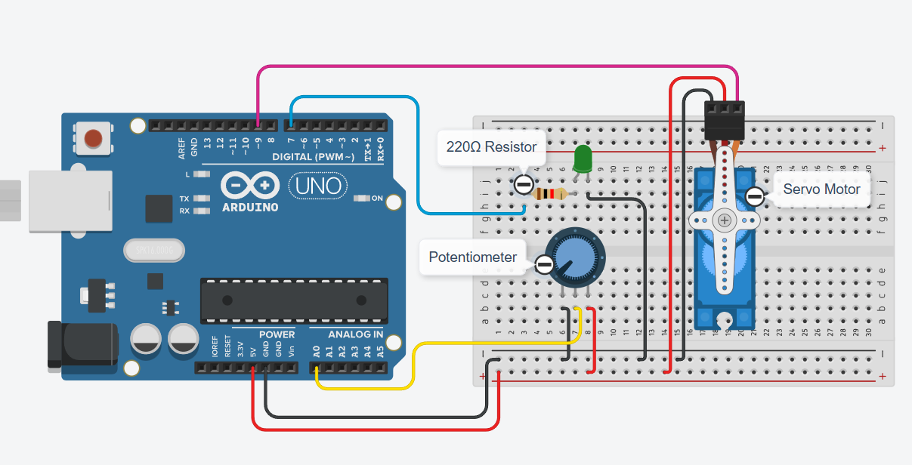

Arduino Code:

#include <Servo.h>

Servo myservo;
const int potPin = ; //Potentiometer pin
const int ledPin = ;
bool stopControl = false;
int potValue, angle;

void setup() {
Serial.begin(9600);
myservo.attach(9);
pinMode(ledPin, OUTPUT);
}

void loop() {
if (!stopControl) {
potValue = analogRead(potPin);

// Map the 0-1023 potentiometer value to a 0-180 degree angle
angle = map(potValue, 0, 1023, 0, 180);
myservo.write(angle);

// LED control: Turn ON when the angle exceeds 90 degrees
if (angle > 90) {
digitalWrite(ledPin, HIGH);
} else {
digitalWrite(ledPin, LOW);
}

// Send the calculated angle to Python
Serial.println(angle);
delay(50);
}

// Listen for the stop command ('x') from Python
if (Serial.available() > 0) {
char command = Serial.read();
if (command == 'x') {
stopControl = true;
myservo.detach(); // Safely detach the servo
digitalWrite(ledPin, LOW); // Turn off the LED
Serial.println("STOP");
}
}
}

Python Script:

import serial
import matplotlib.pyplot as plt
import time

# -- Replace 'COMx' with your Arduino's actual serial port (e.g., 'COM3')
ser = serial.Serial('COMx', 9600)
time.sleep(2) # Wait for Arduino to reset

plt.ion() # Interactive mode for real-time plotting
fig, ax = plt.subplots()
x_vals, y_vals = [], []

print("Plotting real-time servo angles. Press CTRL+C in the terminal to stop.")

try:
while True:
raw = ser.readline().decode().strip()

# Check if the incoming data is a valid number
if raw.isdigit():
angle = int(raw)
print(f"Servo Angle: {angle}°")

x_vals.append(len(x_vals))
y_vals.append(angle)

# Update the plot
ax.clear()
ax.set_ylim(0, 180)
ax.set_title("Real-Time Servo Angle Plot")
ax.set_xlabel("Samples")
ax.set_ylabel("Angle (°)")
ax.plot(x_vals, y_vals)
plt.pause(0.05)

except KeyboardInterrupt:
print("\nSending stop command to Arduino...")
# Send the stop signal to the Arduino
ser.write(b'x')
time.sleep(1)
finally:
ser.close()
plt.ioff() # Turn off interactive mode
plt.show() # Display the final static plot
print("Serial connection closed.")

It should look like this (Ensure that your serial monitor in IDE is turned off, no need to close the whole page, only the serial monitor in IDE):
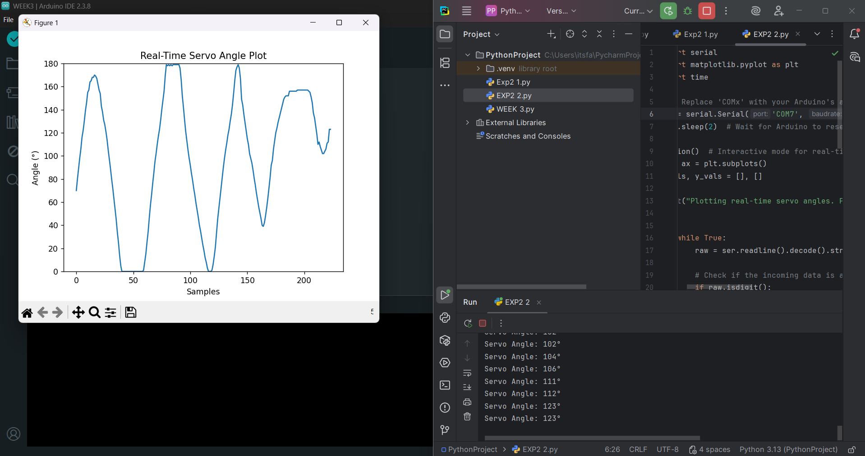
References
- https://lastminuteengineers.com/servo-motor-arduino-tutorial/
How Servo Motor Works & Interface It With Arduino
- https://docs.arduino.cc/tutorials/
Tutorials - From beginner to Advanced
- https://www.instructables.com/Arduino-Servo-Motors/
Arduino Servo Motors

